Game Design Document

Hack the planet

Overview

Product Details

* Players
  + Single Player
* Genre
  + Hacking/Thriller, First Person

Summary

You are a hacker intent on taking control of the world, you are trying to access the main database that contain the key codes to do so.

You must manage through three challenging levels of hacking to obtain the code and ultimate control, but you are limited in time as well before you are traced and found.

Pillars

* Hacking
* Isolative Environment
* Time

Game Loop

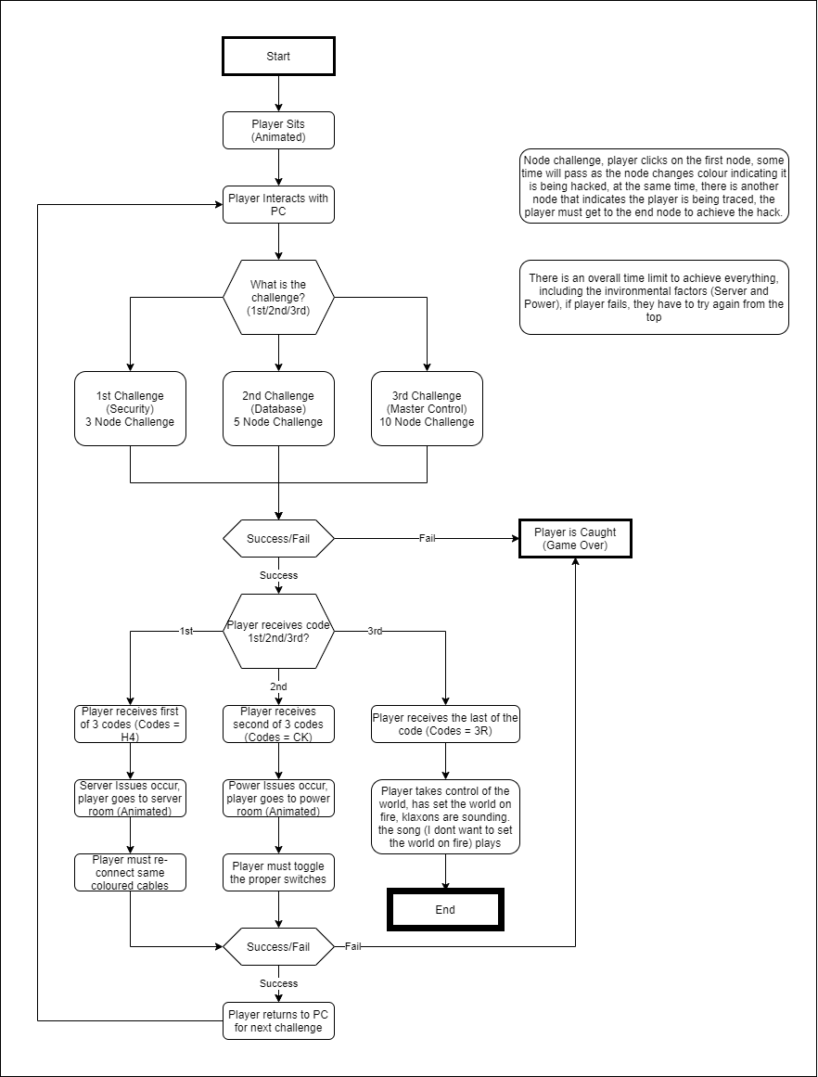

Mechanics

* Interaction
  + Player interacts within the pc.
    - Clicking on nodes on their own pc

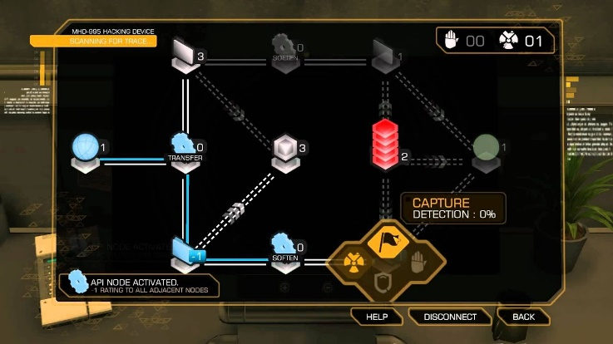

Figure Deus Ex: Revolution, mini game

* + Player interacts with the environment.
    - Player interacts with the server, click and drag the corresponding colour cable to the colour input.

Figure Among Us, mini game

* + Player clicks on switches that display a power value and the sum total on a display (player must match the value to the overall sum power needed)

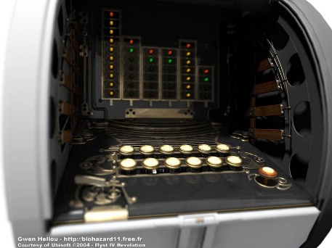

Figure Myst 4, mini game

Systems

* Display
  + Player PC
    - Player pc will display the node system that they interact with to hack into the “world system” or “government system” or “Illuminati incorporated?

Figure Hacknet UI display

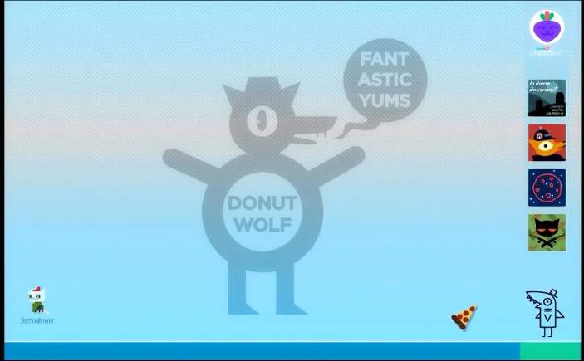

Figure Night in the Woods, Mae's laptop

* + - At the end of each successful ‘hack’ the player is presented with a code

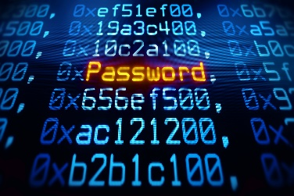

Figure UI Password Display (Stock Footage)

* Time
  + Player has a set amount in which they have to achieve all hacks and issues to achieve victory, otherwise when the timer runs out, they are caught and it is game over.

Controls

* Mouse to interact, click on objects and click and drag
  + Click and drag during the server issues
  + Click on the switches during the power issues
  + Click to interact with the nodes on the pc

Players Progression

When the players have succeeded in hacking, they receive 1 of 3 codes, after 3 levels in total, they receive the final code on the 3rd to achieve victory

The player is limited by the time they have to achieve each challenge and issue, if they fail, they are captured, and the game ends and the player has to start all from the beginning.

Level Design

There are 3 hacking levels and 2 ‘issue’ levels in between and after the last level is achieved, there is a victory where there is a loud bang, klaxons blaring and a bright light indicating the nukes have fallen and the player has been victorious.

1st Challenge

* The player is at the computer dealing with their first challenge, the goal is to click 3 nodes in succession.
* When the player clicks on the first node, they must wait until the node changes from a neutral to a blue colour.
* Another node activates which is red indicating that the player is being traced, and they must complete all nodes before the node reaches the player (Game over for the player)
* If the player has completed the hack, there is a separate display giving the player the 1st of 3 codes.

Server Issue

* The player at the end of a successful hack (the first 2) will suffer a server overload and must reconnect the proper cable colour to succeed to the next challenge (otherwise game over for the player)
* Bonus time (a tiny bit) is given to the player if they succeed.

2nd Challenge

* Much like the challenge as the 1st one, the player in this instance must reach the end node by going through 5 nodes in succession and they will also be traced as the last time.
* If successful, the player is given the 2nd of 3 codes.

Power Issue

* The player at the end of the 2nd challenge now must deal with a power issue (they walk down to a maintenance room to fix a digital power box)
* The player must activate the right switches to get the power back, otherwise the player is caught and game over.

3rd challenge

* Much like the 1st and 2nd, same principle except it is 10 nodes that the player must complete.
* Fail is the same as above.
* Success is the player receiving the last code, that is the end of the game, the player wins and the end of the world has begun